SIR MODAL Design documentation 31/01/2023

Contents

Introduction/Purpose 2

Goals of the Project 2

Actions 5

Code archtecture design 6

User Excperiance 6

Risk 6

Ending 6

Introduction/Purpose

I have been asked to produce a project for my project management course. I have chosen to use Prince2 to produce a digital recreation of the SIR modal. The sir modal is mathematical modal that is designed to predict and replicate the infection rates of a known virus along side with many variations simulating how other factors effect the infection rate of a virus by showing out of a total population how many it can infect the sir modal is based of the first infection modal by Sir Ronald Ross in 1916

Goals of the Project

The major goal of the project is to complete this project while adhering to the principles and stages of prince 2 in order to work out how we can work out if this project will be successful we will have to begin by looking at the goals of the project and what we should strive for the project so we know by the end of the project what the product and the project should of achieves so we have a way to determine a way to work out how successful the project

The first and most important goal of the software that it must serve is the ability to use the base modal of the Sir modal shown Below it must be able to show the rate of infected individuals alongside healthy individuals and those that have recover among those infected and simulate the infection rate based of the base modal.

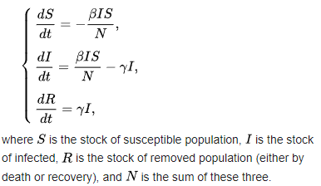

So, to ultimately determine if the project is a success this first goal is completed if the project can do this in any way shape or form the project than the project has fundamentally succeeded. I say this because as long as Prince 2 states that a project must always have a business justification and by making this the base goal I am able to make the product more likely to at least produce a piece of software that can work and do the basic SIR modal so my justification by making this the deciding goal is that as long as something that can recreate the base line SIR modal than the project has created a piece of software so there is some reward from the project and there is a product at the end.

The Second goal of the project I will be setting to enhance the product is the ability to show the results of the sir modal in a graph like format for visual when the software as finished its calculation based on the statics given to the modal the Software should be able to using python to be able to create a graph that is able to accurately and without error should be able to display a graph for the statistics that the user entered and this should work with a wide range of numbers from the user so it should be adaptable in what statistics it should display the software should also need to be able to display the graph on the software and the user for a bonus goal should be able to save the graph for their documentation needs an example of what this would look like is show below

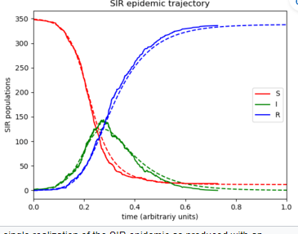

A third Goal of the project should be that the software is that the application should be able to emulate the software with a variation of the SIR Modal and that is the SIRD modal this modal is a variant that also add onto the calculation of the SIR modal that helps show the fatality rate of the virus being tracked this can help work out a fatality rate of a virus this should also be shown onto the graph of the program and this as a optional goal to help track how well the application was completed it should be added on after the base goal is done as the baseline SIR modal is required to be developed before this goal of the project below is an example of the new calculation and what the new graph will look like with this new variation with the SIRD modal.

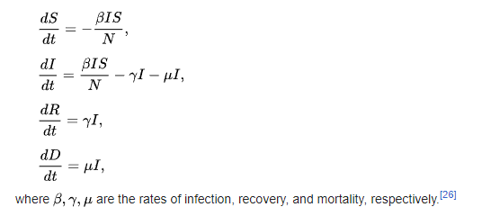 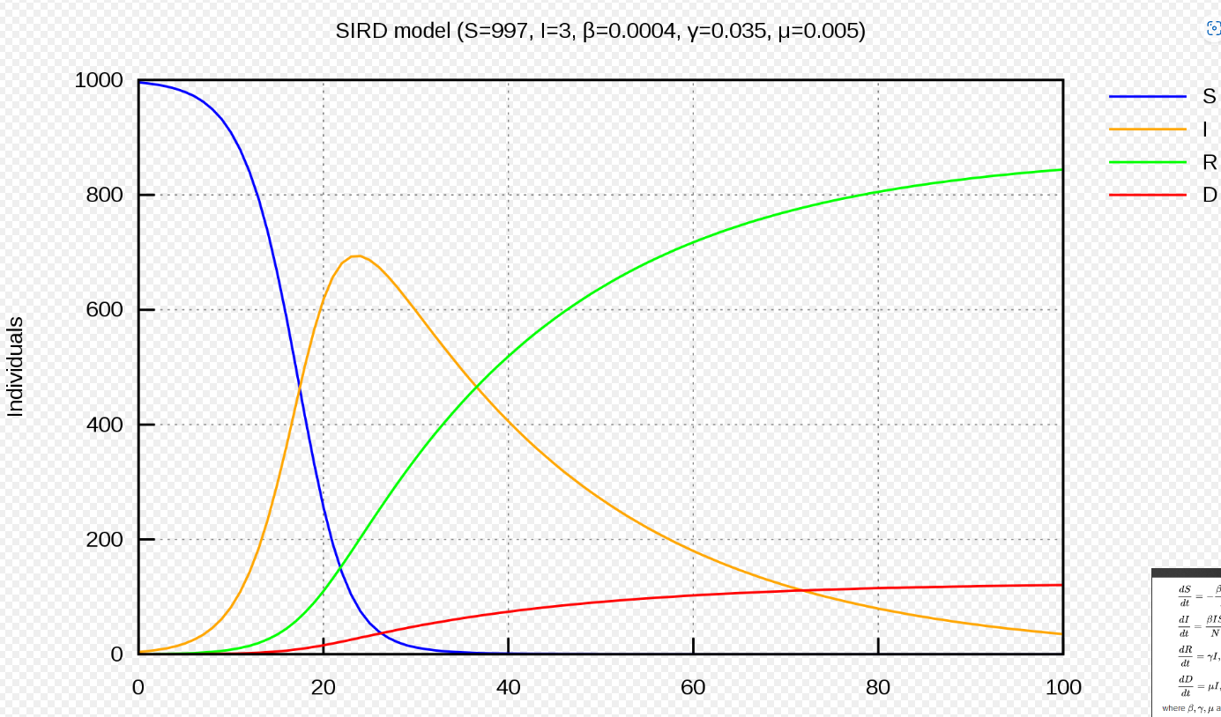

Actions

One action that should be taken for the project to be hosted and have the code stored online with the feature to have developers be able to work together on the project and that platform should be github as it’s the major indistury starderend for a software/code hoster for developers and its holds a high quantity of high quality support featutures that help the developers in the creation of the project by giving more ways to create documentation during the development and github holds a repo feature which lets coders to be able to work together on the project by making their own variant of the project and than merging it with the main project when approved giving all coders the new version and keeping the changes on their version and by letting coders know what changes have been made with any new version

**Development Cycle**

One of the imidtae action that must be taken is the delegation of whom will be responsible for which parts of the code architecture of the software and than begin the work on the software of the project one the code part of the project si done the developer of that part of the software must than begin to document the changes and the making they made to follow pruince 2 pricipe which is to create as much documentation as possible this will also fall into the stage of prince 2 whichis the control of the project t otherwise know as the development phase of the project this will also help the development as it will lett people know what changes have been made per development cycle

In the devlopment cycle after a change is made it should always be needed for thye project to be tested by the one who made the changes so that project holds more documentation to support i9ts devloment and its quality and that the project is able to maintain itd quality which is a major part of prince 2 by making susre every feature that is added is of a working quality

When it comes to the end of week of the devlopment what was progressed for the project must be documented inside the project tracker so the time scale of the project and what progress is being done is known on the project and the tracker should hold an overview of the project so that the state of project is known and it can bee seen if its keeping a good progress

All of the actions in the development Cycle should be reapted for as long as the software of the project is being devolped and should be reapted in the order displayed while developing the project and thoughtout the development everyone should know what part they are holding in the project which is a major important part of prince 2 whichb is the roles of prince 2 makin g it important that through the entire development that people know what they are devolping its also important to constantly mointer the progress of the project with the project tracker as checking proress with the time given is a major principle of Price2

**After development cycle/managing product delivery**

Once the devlopment has been finished the first action that must be taken when for the project is by testing the project as a whole which allows us to uphold prince2’s principle of creating high quality products and by doing this we can assuare the project works and by doing this it finished the managing project stage of prince 2

One imidite action to take after the devlopment phase is to begin to write a finished report on the project esplaining on hwo well the software sticks to the code artchiture and any changes that were made during the devlopment to the code artechure so that we know what the code making up the software consists off the finished report on the dsoftware should also be able to show evidence and exsplnations 0of the different objectives on what we had for the software and what we did during the devlopment phase to reach these goals and how the software is able to carry out these goals that were set for the project or the failure of the software being able to conduct successfully the goals of the project. Showing how the project was able to complete the set goals is a major part of the manging the product delevry phase as manging and using goals to detimin the project success is a major aspect of prince 2 and this is shown in the creation of finished software report the finished project t report should also be able to exsplain how the project is in a good state and does not need any more devlopment time which iws another major aspect o the managing delivery phase of prince2 and so this should also be exsplained in the finhsed report of the software

Code archtecture design

When it comes to what we are storing for the software we need to look at what global variables we will be using as these are needed for the storage pof data which will be used in the sir modal so we will need to be able store the numbers needed by the sirm modal with an appropriate name

**Global Variables-relating to the virus**

Infectivity rate = user input

Recovery rate

Mortality

rate

**Global varible-relating to the modal of the population**

Susetible

Recovered

Deceased

Infected

User Excperiance

The user should be first be shown a menu of the sir modal with an option to start the modal and other options that might be added depending on the completion of the goals and there is extra time such as a esplnation screen of the sir modal and than the user should be shown a new screen of the application with a new choice of the virus they wish to simulate with the option to be able to use a template virus of a known virus or anotherchoice to enter the needed values of the sir modal of a custom virus of their choice the user should be than shown to a virus response screen to help input the values of counter measures for infection and than after that the user should be show to the results of the test of the sir modal wethaer this is a simple list of the days and numbers of a graph depends on weather an addatnial goal is achieved

**The main menu screen**

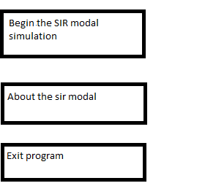

**Simulation screen**

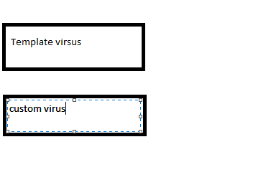

Risk

1)that we fail to complete the main task because of time constraint

2)that we fail to complete the main task because of inability of coding skill

3)the website fails to host the program

4) the program breaks because of a python update

5)me or my partner are unable to continue the work on the software because of personal reasons

6)Me or my partners computer could break for a varity of reasons

Ending

Overall I believe the provided information and this design document will help lay out clearly the foundation of the software and its development with the actions we will be taking to develop the software